
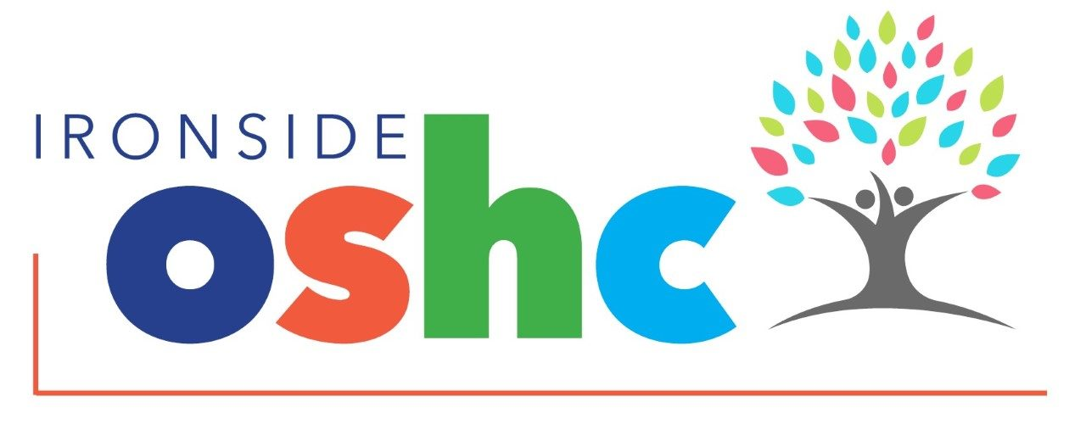
AROUND THE COUNTRY
World Wetlands Day ------------------------------------------- 2
World Read Aloud Day ---------------------------------------- 4
Safer Internet Day ----------------------------------------------- 10
Chinese New Year ---------------------------------------------- 17
Summers Day ---------------------------------------------------- 28
Ramadan ---------------------------------------- Feb 16 – Mar 18

PHONE ISSUES – PLEASE CALL MOBILE
Please be aware we are currently having problems with the service landline. This is due to restricted access of WIFI within the current building.
We are hoping to get this resolved as soon as possible; however, it appears that we may need to look further into internet options for the current space we are using. Please call the service mobile line if you need to contact us as it has better reception.
MOBILE: 0406 739 756

ON ROSTER (RECENTLY EMPLOYED)
Charlie – Studying Bachelor HPE
Claudia – Studying Bachelor of Business / Creative Industries
Ethan – Studying Bachelor of Business Management
Harry S – Studying Bachelor of Business Financial Planning
Isaac – Studying Cert 3 in OSHC
Jake – Studying Bachelor of Commerce
Mitchell – Studying Bachelor of Sport
Nell – Studying Bachelor of Primary Education
Elizabeth – Studying Bachelor Primary Education
Manon – Bachelor of Primary Education

TRIAL SHIFTS (WILL EMPLOY 4 FROM THE TRIALS)
Ruth – Bachelor Biomedicine
Sophie – Bachelor Secondary Education
Tex – Bachelor of Primary Education
Helen – Bachelor of Law and Science
Hannah – International Studies
Dylan – Bachelor Senior Education & Counselling
Emilia – Occupational Therapy
Faye – Speech Pathology

New Educators
We welcome the following new educators to Ironside OSHC in 2026.
In life, there is nothing better than laughing, especially a laugh when you most need it – CATHERINE O’HARA

QLD FOOTBALL & BRISBANE ROAR:
We are excited to have an ASC additional activity for the remainder of Term 1. Soccer is commencing week 6 at OSHC from 3.15pm-4.15pm on Tuesday afternoons. If you come to OSHC on Tuesday, please use the QR code to register and pay the required fee. Also complete the Expression of Interest form sent out via email to all families. recently.


GREEK YOGURT CHOC CHIP MUFFINS

🚸 Important Reminder:

Signing Out & Leaving the Premises
PREP 10 min | COOK 20 min | SERVES 12-15


- Pre-heat the oven to 180 C, line a muffin pan with muffin liners. Spray lightly with oil.
- Combine the dry ingredients in a large bowl.
- Combine the wet ingredients in a jug or smaller bowl.
- Pour the wet ingredients into the dry and mix with a wooden spoon until just combined (a few lumps are fine. Don’t overmix). Add a little more milk if necessary (the mixture will be quite thick but it shouldn't be dry).
- Gently fold the chocolate chips into the batter.
- Spoon the batter into the muffin cases (you can fill almost to the top) and bake for 17 to 25 minutes.
- After 17 minutes keep checking every couple of minutes. A skewer pushed into the centre of the muffin should come out without raw batter on it, and the muffins should be nicely golden brown.

Let cool completely on a wire rack before eating so that the muffin cases don’t stick. Reheat for 15 seconds in the microwave after peeling off the muffin case if you’d like to enjoy a muffin warm!
Enjoy x
Find this recipe and more at Scrummy Lane
⅔ cup un-flavoured oil,
1 cup Greek yogurt,
¼ cup milk, (¼ to ½ cup)
1 teaspoon vanilla extract
1.5 Cup choc chips

INGREDIENTS
2.5 cups plain flour
1 tbs baking powder
½ tsp baking soda
½ tsp salt
⅓ cup sugar
2 eggs, lightly whisked

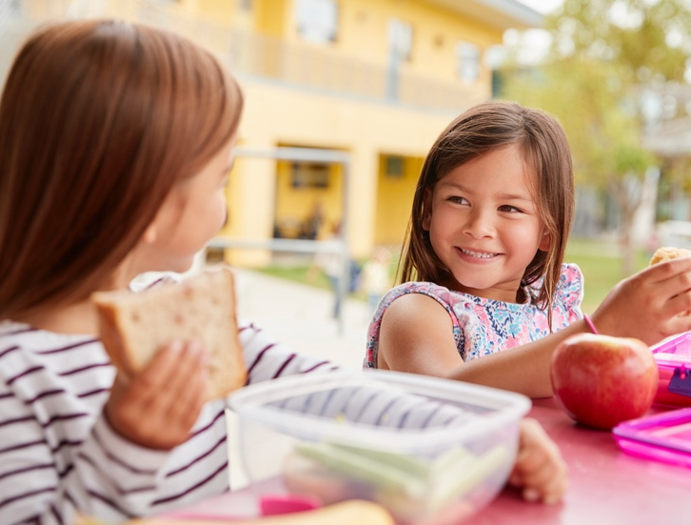
We kindly ask all families to please leave the OSHC premises promptly once your child has been signed out.

When children remain in the space after being signed out, it becomes difficult for educators to accurately determine which children are still in our care. This impacts our late afternoon head counts and supervision

processes, which are essential for maintaining a safe environment.
It also creates potential safety risks — not only for the children officially in our care, but for educators and younger siblings (including toddlers) who may still be on site.

To help us maintain accurate supervision and ensure the safety of everyone in our community, please ensure that once your child is signed out, you exit the OSHC area promptly.

Please remember that a parent or authorised carer must sign the child out. Children are not permitted to sign themselves out. This is a legal requirement and must align with our service policies and regulatory obligations.

We appreciate your cooperation and support in keeping our service safe and well-managed for all families.

Even if your child does not have an allergy, allergy awareness is an important part of keeping children safe in schools, and the wider community. Food allergies are increasingly common in young children, which means most children will share spaces, meals, and activities with peers who have allergies at some point.
Understanding what allergies are, what to look out for, and how to talk to children about allergy safety helps create a safer and more inclusive environment for everyone.
What Families Should Know
A food allergy occurs when the body reacts to a food that is usually harmless. Common allergens in school-age settings include peanuts, tree nuts, eggs, dairy, wheat, soy, and sesame. Reactions can range from mild symptoms, such as hives or stomach discomfort, to severe reactions that require urgent medical attention.
While children are not expected to manage allergies themselves, understanding that “some foods can make people very unwell” helps them appreciate why certain rules exist at school and care.
Teaching your child to be allergy aware
As children grow, they can understand clear safety expectations. Allergy awareness can be explained calmly and practically, without fear.
Helpful messages to reinforce include:
“We don’t share food or drinks.”
“Everyone’s body is different, and some foods can be dangerous for others.”
“If you’re unsure, always check with an adult.”
These simple rules support safety while encouraging children to take responsibility for their choices. Children often want to help and do the right thing understanding why rules matter makes them more likely to follow them independently.
Everyday Habits That Support Safety
Parents can support allergy awareness by reinforcing consistent routines at home, including:
- Reminding children that lunchboxes are just for them
- Encouraging regular handwashing before and after eating
- Modelling respect for school and care food rules

HEALTH AND SAFETY: Allergy Awareness: What All Families Need to Know

?



Decompression after a big school day
After a full day of learning, socialising and following routines, children often need time to decompress. After-school hours
are an important opportunity for kids to slow down, reset and transition out of “school mode”. Quiet activities such as
drawing, reading, building or spending time outdoors can help children relax and regulate their emotions. Offering water, a healthy snack and
a calm environment supports tired bodies and busy minds. Decompression time helps children process their day, reduce stress and feel ready
for the rest of the afternoon. When children are given space to unwind, they are more settled, focussed and better able to enjoy their time
at home or in care.
These habits not only support allergy safety, but also build independence, hygiene awareness, and respect for others.
Supporting Awareness Without Anxiety
It’s important that allergy awareness doesn’t create worry or pressure for children. Children should not feel responsible for managing someone else’s health. Instead, they need clear rules, calm explanations, and reassurance that adults are there to keep everyone safe.
Keeping conversations factual and positive helps children understand safety expectations without fear.
Building Empathy and Inclusion
Allergy awareness is also about kindness and inclusion. Explaining that some children need different food to stay healthy helps build empathy and understanding. These conversations support social skills, respect for differences, and a sense of community.
Allergy awareness helps children grow into thoughtful, considerate individuals who understand that keeping others safe is part of being part of a community.

For more information on allergy awareness follow the QR code.
Source: Health Direct (2023). Food allergies in children. Retrieved from healthdirect.gov.au


- Reducing after-school commitments where possible
- Offering connection before conversation
Children don’t always need to talk about their day straight away. Sitting together, playing, or sharing a calm activity can help them feel safe enough to open up later, if they choose to.
What Not to Push Right Now
End of term is not the ideal time to introduce big changes or push extra demands. If possible, try to avoid:
- Starting new routines or expectations
- Pushing for “perfect” behaviour
- Overloading evenings with activities
- Expecting the same level of focus or patience
This doesn’t mean letting go of boundaries it means being realistic about what children can manage when they’re tired.
Adjust Expectations, Not Care
Supporting children at the end of term doesn’t mean lowering standards forever. It means recognising where they are right now. Gentle reminders, extra patience, and consistent routines help children feel safe and supported until they can rest and reset. When adults respond with understanding instead of frustration, children learn that their feelings are valid and manageable. This builds trust, emotional safety, and resilience skills that matter far beyond the classroom.

As the holidays approach, remember falling apart at the end of term is often a sign that children have been working very hard. With rest, connection, and a little less pressure, most children bounce back quickly. Sometimes, what helps most is simply knowing this phase is normal and temporary.

If your child seems more emotional, tired, irritable, or “not themselves” as the end of the school term approaches, you’re not alone. Many families notice behaviour changes in the final weeks of Term 1 and there’s a good reason for it.
Children manage a huge amount each day. They follow routines, concentrate for long periods, navigate friendships, regulate emotions, and meet expectations often for six hours or more. By the end of term, this sustained effort can lead to mental, emotional, and physical fatigue. When children run low on energy, their ability to cope, regulate emotions, and manage behaviour also drops. This doesn’t mean children are being difficult or defiant. It usually means they are tired and overloaded.
What’s Going On Beneath the Surface
By the end of term, children may be:
- Holding in emotions all day and releasing them at home
- Feeling pressure from assessments, activities, or routines
- Experiencing physical tiredness from busy schedules
- Managing social challenges and friendships
- Using up their “regulation reserves”
When those reserves are low, children may cry more easily, argue, withdraw, struggle with transitions, or react strongly to small things. This is a sign they need support not stricter expectations.
How Families Can Help
The most helpful thing parents can offer at this time is decompression. After school, children benefit from time to slow down and reset.
Helpful strategies include:
- Offering water and a nourishing snack
- Allowing quiet or low-demand activities
- Spending time outdoors

FOCUS ARTICLE: Why Kids Fall Apart at the End of Term (and What Helps)

?

MAKE YOUR OWN CLEANING PRODUCTS

Turn cleaning day into a science experiment and mix up some non-toxic sprays and solutions to use around the house with your child. Combine baking soda with warm water to create a deodorizer or simple kitchen cleaner, and use it to wipe down the inside of your microwave or refrigerator. Or, mix dish soap with warm water to clean the countertops.
When you make your own cleaners you save money, reduce your toxic load and reuse bottles you would have usually thrown out! You can find a large range of recipes here

Read the article via the
QR code.
Source: raisingchildren.net.au (2020). Household chores for children. Retrieved from https://raisingchildren.net.au/toddlers/family-life/routines-rituals/chores-for-children

This Month we have been working towards enhancing the following Quality Areas:

Quality Area 2 – Revising our current Menu and offering a more variety of options for afternoon tea that children can choose from.
Quality Area 2 – Registering for childcare safety reform.

Quality Area 5 – Training on supporting children to self-regulate and respond appropriately to their behaviour and that of other by communicating effectively to resolve conflicts.

For information on managing emotions follow the QR code.
Source: Health Direct (2025). Understanding and managing emotions. Retrieved from healthdirect.gov.au

QUALITY IMPROVEMENT CORNER
Over the next month we will be re visiting our service Philosophy and asking children to adapt a child centered service philosophy.

We would love to see more families on our service Facebook page and for parents to make comment on our posts and the activities that children have been directly involved in. The more involvement from families the more inspiration we have to ensure our service can offer the best possible care for all children.
Please use the below link to be part of our page.

https://www.facebook.com/share/g/1E2xMY8rKr/

Week 1 

Art Den: Indigenous Dot Painting
Oval: Soccer games, volleyball, relay races, Wana (indigenous games)

Leisure Loft: Foosball, just dance, small construction
Hall: Edor (Indigenous game) Handball, badminton, dodgeball

WHATS BEEN HAPPENING AT OSHC SINCE LAST NEWSLETTER

Week 3
Art Den: Winter Olympics -design your own snowboard, Valentines Day Craft

Oval: Slackline, Frisbees, Fitness Challenges, Indigenous games, Cricket
Leisure Loft: Minute to Win it Challenges, Valentines Day Garland Making
Hall: Dodgeball, Futsal, 3 Pin Challenge

Week 2

Art Den: Friendship bracelet making, Paper plate disco balls, Waitangi Day creations (NZ)
Oval: Cricket, Julba, Bram Bahl, badminton, Soccer

Leisure Loft: World’s Wetlands Day, Tu Bishvat (Jewish New Year for Trees,) Lego, Board games club

Hall: Dodge Frisbee

Week 4
Art Den: Chinese New Year Fork Painting, Bookmark Making, Finish the Comic, Hama beading, STEM bird feeders
Oval: Hula hoops, skipping, playground, Baseball, Soccer
Leisure Loft: Small construction, Lego, Board Games Club, watching the Winter Olympics
Hall: Futsal, Mobile basketball, Indigenous games

CHILD SAFETY REFORM 2026

Child protection in Australia in 2026 features major, mandatory, nation-wide reforms in Early Childhood Education and Care (ECEC) starting 27 February 2026. Key changes include mandatory national child safety training for all staff/volunteers, strict device usage policies, and "inappropriate conduct" offenses. Queensland is implementing a Reportable Conduct Scheme from 1 July 2026.

MANDATED CHANGES
Mandatory Training: All staff, volunteers, and students in ECEC must complete new, nation-wide, approved child safety training.
Device Policy: Strict rules mandate only service-supplied or approved devices for taking images/videos, banning personal devices when working directly with children.
"Inappropriate Conduct": New, broader offenses and regulatory responses for misconduct are introduced.

ALL IRONSIDE OSHC EDUCATORS HAVE REGISTERED FOR THE NEW TRAINING

NEW MENU TRIAL-

y
GREEN SLIP CONGRATULATIONS FOR FEBRUARY
These Students already have 5 or more GREENSLIPS
Hayden P (1) | Raylan (1)
Effie (P) | Ananya (P)
Oscar R (6) | Eleanor (P)
Presitha (6) | Emma M (2)
Sohana (6) | Olia (6)

FEEDBACK

WWW.IRONSIDEOSHC.ORG.AU
Email: contactus@ironsideoshc.org.au Phone number: 0738709849

Stretch & Breathe
Short simple activities to get some active minutes in the day.
This gentle movement activity is a lovely way for families to slow down and reconnect at the end of the day.
Find a quiet space, stand or sit together, and
move slowly through each action.
Try:
- Reach arms up high and stretch tall, then lower them slowly
- Bend down and touch toes or reach toward the floor
- Roll shoulders forwards and backwards
- Gently twist side to side
- Finish by taking three slow, deep breaths together
Encourage children to notice how their bodies feel as they move and breathe. This activity supports calm bodies, emotional regulation, and helps children transition from busy days into relaxed evenings. It’s a simple way to build healthy movement and mindfulness into everyday family routines.


🥪 Menu Update – Term 2
At Ironside OSHC, we are proud to offer a menu that supports a wide range of dietary requirements and provides nutritious, enjoyable options for all children.
To ensure we are continuing to meet the needs and preferences of the children, we will be making a small adjustment to our afternoon menu beginning in Term 2.

The updated menu will include:
- A selection of savoury wraps or sandwiches (varies by day)
- A choice of sides, including yoghurt, rice cakes and rice crackers
We will be trialling this menu for the duration of Term 2 to evaluate how well it meets the children’s needs, as well as to ensure it remains cost-effective and manageable for our kitchen team.
As always, we will continue to cater for individual dietary requirements and allergies in line with children’s enrolment information.
We welcome any feedback during the trial period.

Your feedback is important to us, please use the below QR code to lets us know how we are doing. All feedback will assist in ensuring your and your childrens ideas and views are being heard.


